Sennheiser expands AMBEO Immersive Audio with new cooperation and technologies

Wedemark, March 8, 2018 – Sennheiser is strengthening its position as a leading provider of immersive audio solutions with an investment in Dear Reality, experts in spatial audio algorithms and audio VR/AR software, and the acquisition of technologies from Sonic Emotion, a developer of award-winning 3D audio software and processing solutions. Both companies have developed unique expertise and tools for the creation and rendering of immersive audio in object-based and scene-based formats.


“We are excited to be complementing our broad AMBEO expertise with additional capabilities in the areas of processing, controlling and reproducing object-based immersive audio,” said Daniel Sennheiser, co-CEO of Sennheiser. Co-CEO Dr. Andreas Sennheiser added: “Augmented audio will play a huge role in the future, and this expansion will further strengthen our position as the go-to experts in the field of augmented and mixed reality applications.”

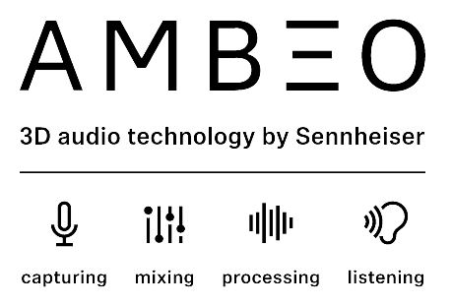 | Sennheiser has strengthened its leading position in immersive audio by investing in Dear Reality and acquiring intellectual property from Sonic Emotion.
Dear Reality GmbH (dear-reality.com), based in Germany, has specialized in innovative software tools for the professional audio production of both interactive and linear content in VR/AR. The company is acclaimed for its immersive audio plug-ins, state-of-the-art algorithms and custom software for development platforms and interactive apps. Dear Reality’s Spatial Connect software enables an innovative, fully immersive workflow for VR/AR audio productions, while dearVR is a 3D audio engine for digital audio workstations and interactive platforms such as Unity. Both solutions have met with an enthusiastic response from the audio and VR/AR industries and the specialist press alike.

Dear Reality co-CEOs Achim Fell and Christian Sander commented: “With Sennheiser, we share the conviction that immersive audio is the future of audio productions and that augmented audio will become important for our everyday life. We are very happy to have found a strong partner in Sennheiser that will enable us to develop high-quality software solutions for immersive audio production and perception. Our products close the gap between recording equipment and reproduction hardware to create a comprehensive production workflow that is is compatible with every headphone in the world.”

The acquisition of technologies from Swiss-based Sonic Emotion brings immersive audio solutions for soundfield control and loudspeaker playback to Sennheiser’s AMBEO technologies. Sonic Emotion’s object-audio workflow and 3D software licensing portfolio enable an immersive, fully natural audio experience for a multitude of consumer devices including soundbars, headphones, boomboxes, laptops and smartphones.

Renato Pellegrini, co-founder of Sonic Emotion AG who joined the AMBEO team in January, commented: “The algorithms developed by Sonic Emotion will now be combined with the strong product portfolio and algorithms of Sennheiser. There is a huge potential in our joint expertise, and I am very much looking forward to the resulting products, which will make the future of audio ever more real for our customers.”

About Sennheiser
Sennheiser is shaping the future of audio – a vision built on more than 70 years of innovation culture, which is deeply rooted within the family-owned company. Founded in 1945, Sennheiser is one of the world’s leading manufacturers of headphones, microphones and wireless transmission systems. With 20 sales subsidiaries and long-established trading partners, the company is active in more than 50 countries and operates its own production facilities in Germany, Ireland and the USA. Sennheiser has around 2,800 employees around the world that share a passion for audio excellence. Since 2013, Sennheiser has been managed by Daniel Sennheiser and Dr. Andreas Sennheiser, the third generation of the family to run the company. In 2016, the Sennheiser Group had sales totaling €658.4 million. www.sennheiser.com

Global Contact

Mareike Oer
mareike.oer@sennheiser.com
+49 (5130) 600 – 1719

